NPS 2320030205

EXPERIMENT-2 N. Manasa Lahari

AIM: Execute the following networking commands like **ipconfig, tracert, telnet, netsh, ping, nslookup and netstat** in the command prompt with simple topology.

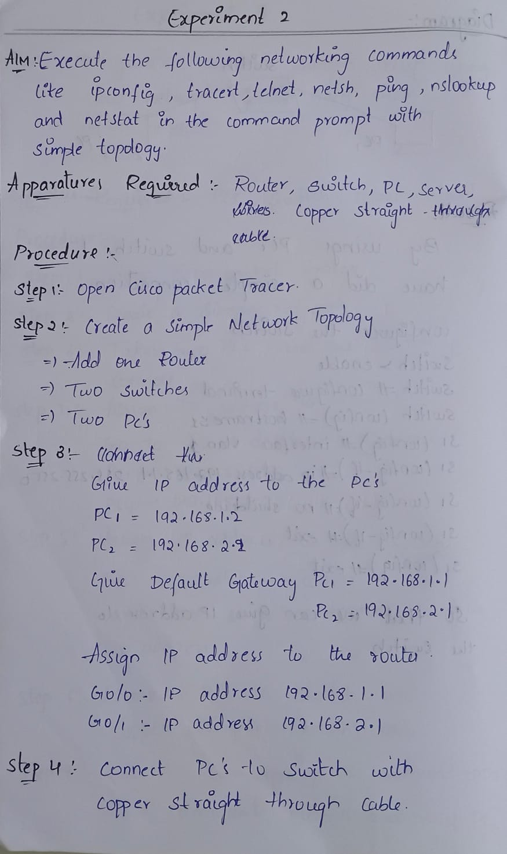

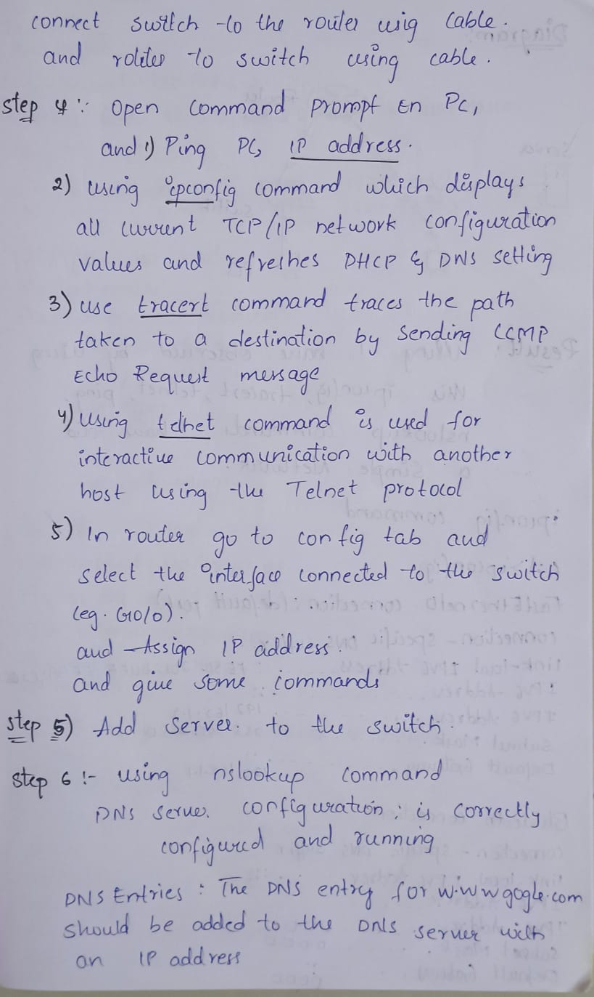

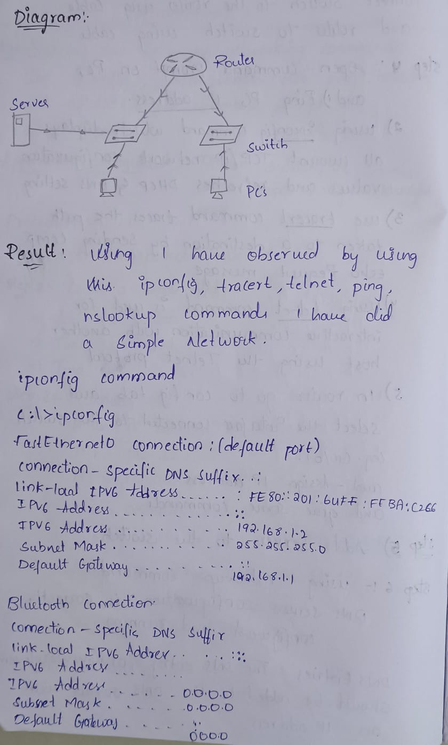

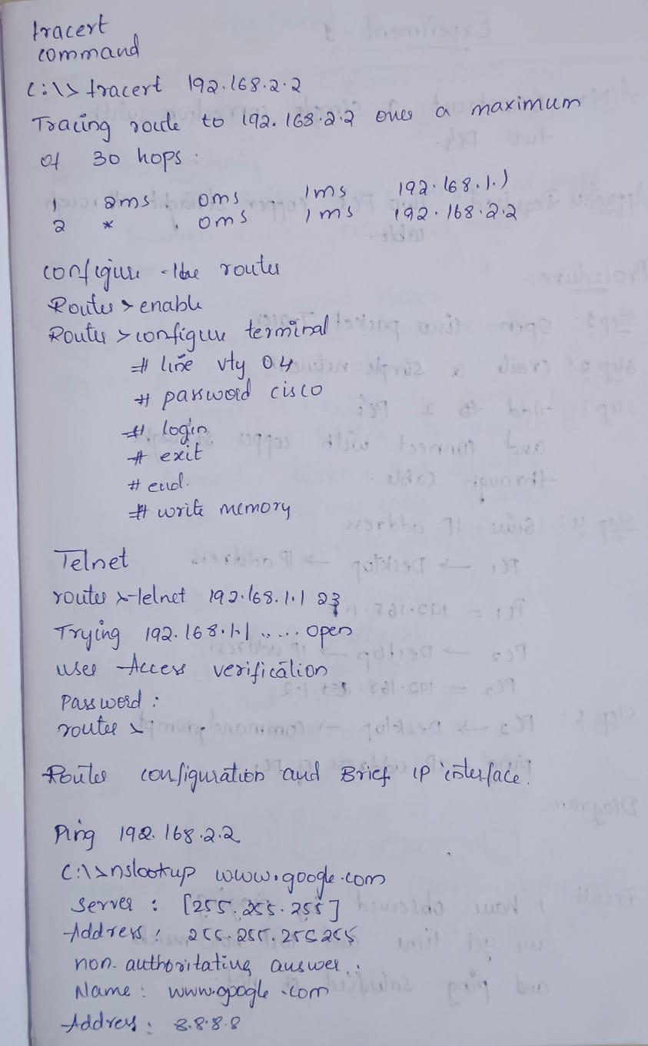

Configure the router:

Interface G0/0: IP address 192.168.1.1, Subnet Mask 255.255.255.0

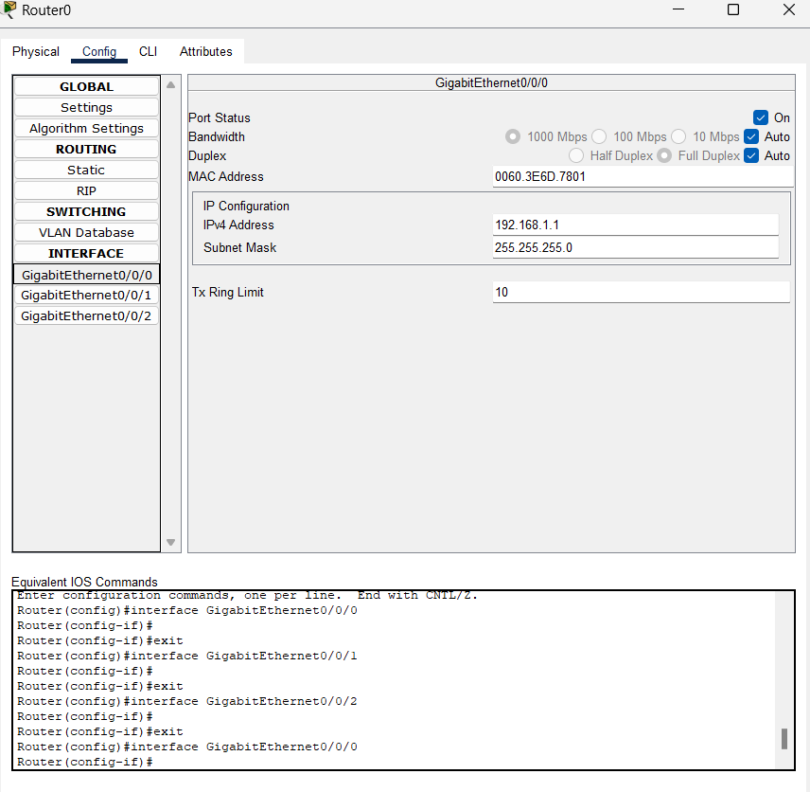

Interface G0/1: IP address 192.168.2.1, Subnet Mask 255.255.255.0

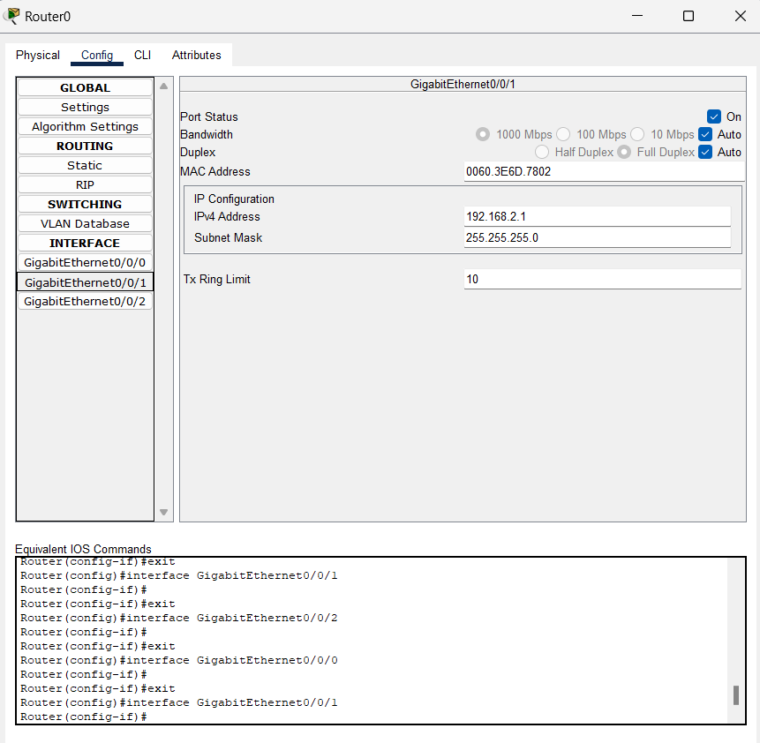

**Configure the PCs**:

PC0: IP address 192.168.1.2, Subnet Mask 255.255.255.0, Default Gateway 192.168.1.1

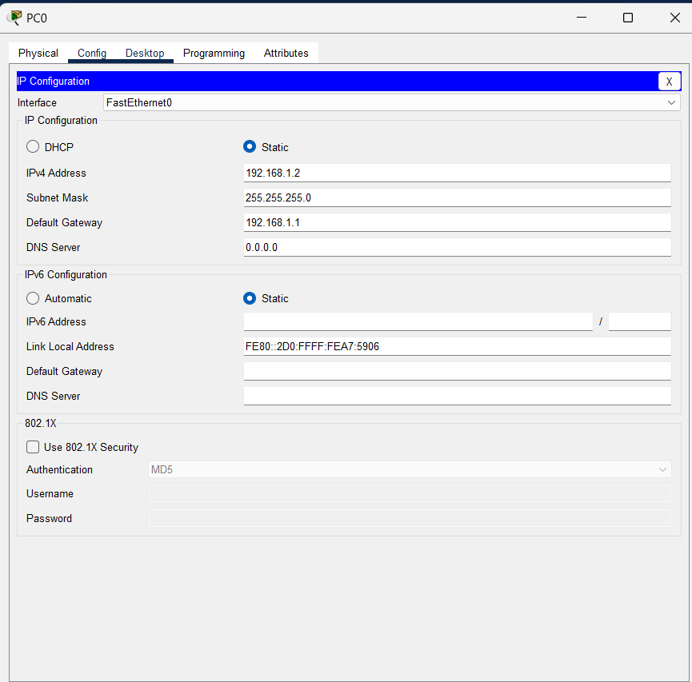

PC1: IP address 192.168.2.2, Subnet Mask 255.255.255.0, Default Gateway 192.168.2.1

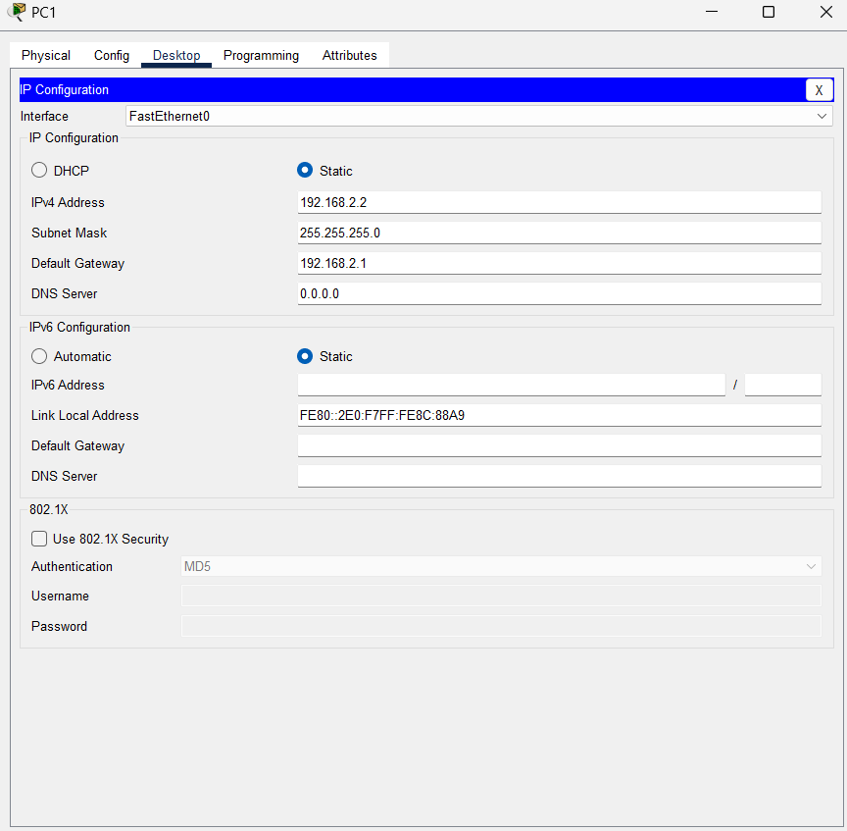

**Execute Networking Commands**

**1. ipconfig**:

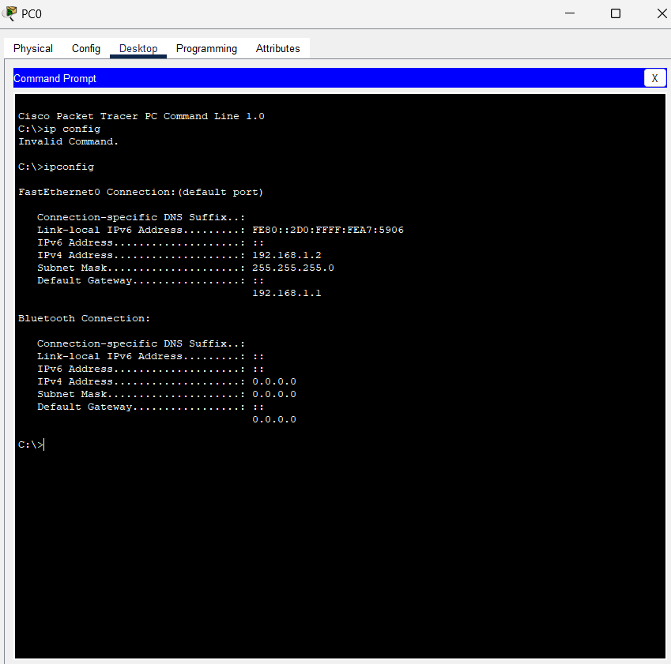

2. **tracert**:

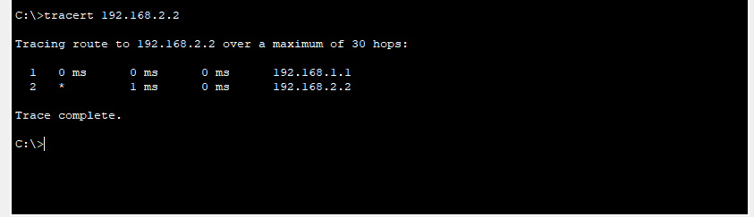

***Configure the Router***

1. **Assign IP Address:**

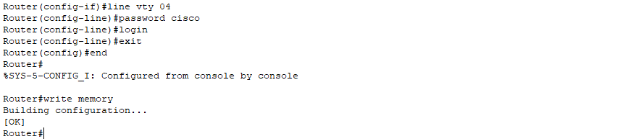

3. telnet

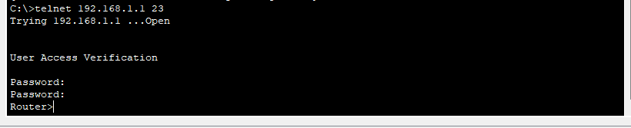

4. Router configuration and Brief Ip Interface

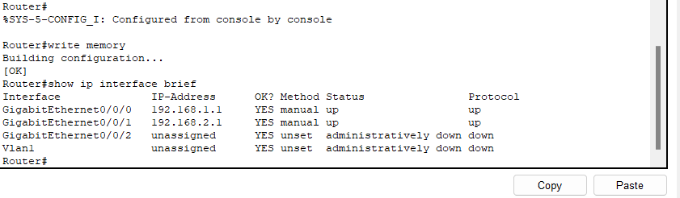

5. **Ping 192.168.2.2**

**ICMP Echo**

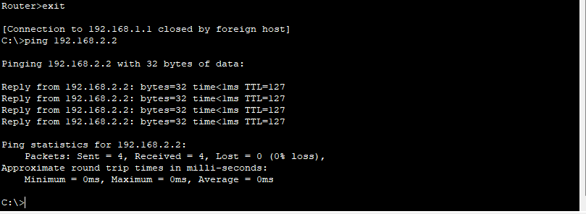

1. **Add one server (to act as a DNS server).**
2. **Connect both PCs and the server to the switch using copper straight-through cables.**

**Configure the DNS server**

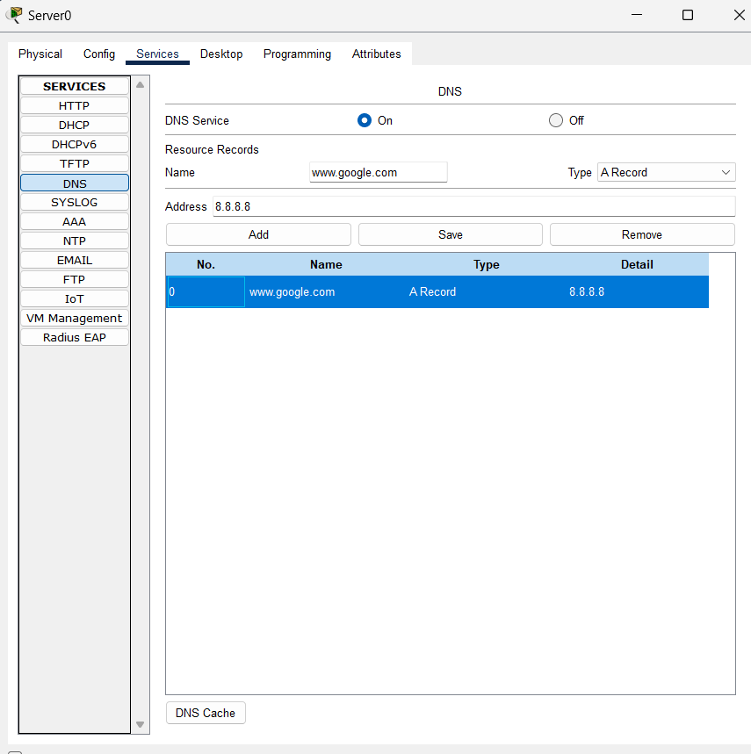

**6. use nslookup command**

